MORSE CODE TRANSLATOR

END TERM REPORT

by

Nidhi Bharti, Shivanshu Singh and Kumari Sneha

Section: K19QK-G-1

RollNumbers:
RK19QKA02, RK19QKA09, K19QKA21



Department of Intelligent Systems,
School of Computer Science Engineering
Lovely Professional University, Jalandhar
November, 2020

Student Declaration

This is to declare that this report has been written by us. No part of the report is copied from other sources. All information included from other sources have been duly acknowledged. We aver that if any part of the report is found to be copied, we are shall take full responsibility for it.

Signature:

<<Signature of the condidates>>(Due to Covid 19, signature is exempted )

Name:

Nidhi Bharti
Shivanshu Singh
Kumari Sneha

Roll Number:

RK19QKA02
RK19QKA09
RK19QKA21

TABLE OF CONTENTS

TITLE PAGE NO.

1. Background and objective of project assigned 5
1.1. Introduction 5
1.2. Background 6
1.3. Motivations 8
1.4. Out-come of the project 11
1.5. Concrete goals 12
1.6. Applicability 13
1.7. Objectives 14
2. Description of project 15
3. Roles among students 18
4. Implementation of scheduled work of project 19
5. Technologies and framework used 21
6. SWOT analysis 23
7. Implementation 24
8. Conclusion 24
9. References 25
 |  | 1. Background and objectives of project assigned | 1
 |  | 1.1. Introduction | 1
 |  | 1.1.1 .................................................................................... | 3
 |  | 1.1.2 ..................................................................................... | 5
 |  | 1.2 ......................................................................................... | 7
 |  | 1.2.1 ..................................................................................... | 7
BONAFIDE CERTIFICATE |  | 1.2.2 ..................................................................................... | 9
Certified that this project report “MORSE CODE TRANSLATOR” is the bonafide work of “Miss Nidhi Bharti, Mr Shivanshu Singh and Miss Kumari Sneha” who carried out the project work under my supervision. |  | 1.2.3 ..................................................................................... | 10

<<Signature of the Supervisor>>(Due to Covid 19, signature is exempted )
Dr. Dhanpratap Singh
UMS ID: 25706
School Of Computer Science
And Engineering

Chapter 1: BACKGROUND AND OBJECTIVES

Subchapter 1.1: INTRODUCTION

This is the implementation of a morse code translator using Python.The translator makes use of a programming language as a key and a simple algorithm of changing characters to dots and dash and vice versa.

This can be used in different areas like morse code for ships at sea to communicate over long distance using large lights. Morse code is mainly used in world war because it greatly improved the speed of communication.

Morse code is represented by the form of dits and dahs. Here dits refer to dots and dahs refer to dash. Morse code used to transmit only numerals at first. After that, Alfred Vail included letters and characters. Morse code can be transmitted by using electric telegraph wire, light, and sound, through a different medium in different ways. Tap code is used by American prisoners. Morse code is used for long-distance communication.

International Morse code was devised by European nations in 1851. It is the base for the morse code to transmit or receive. Morse code is a character encoding and decoding scheme.

Morse code dictionary: 1851 established an international version

A | . - | N | - .
B | - . . . | O | - - -
C | - . - . | P | . - - .
D | - . . | Q | - - . -
E | . | R | . - .
F | . . - . | S | . . .
G | - - . | T | -
H | . . . . | U | . . -
I | . . | V | . . . -
J | . - - - | W | . - -
K | - . - | X | - . . -
L | . - . . | Y | - . - -
M | - - | Z | - - . .

Subchapter 1.2: BACKGROUND

Morse code was invented by an American called Samuel Finley Breese Morse, (1791-1872). He was not only an inventor but also a famous painter.

Before the invention of the telegraph, most messages that had to be sent over long distances were carried by messengers who memorized them or carried them in writing. These messages could be delivered no faster than the fastest horse. Messages could also be sent visually, using flags and later, mechanical systems called semaphore telegraphs, but these systems required the receiver to be close enough to see the sender, and could not be used at night.

The telegraph allowed messages to be sent very fast over long distances using electricity. The first commercial telegraph was developed by William Forthergill Cooke and Charles Wheatstone in 1837. They developed a device which could send messages using electrical signals to line up compass needles on a grid containing letters of the alphabet. Then, in 1838, Samuel Morse and his assistant, Alfred Vail, demonstrated an even more successful telegraph device which sent messages using a special code - Morse code.

Telegraph messages were sent by tapping out the code for each letter in the form of long and short signals. Short signals are referred to as dits (represented as dots). Long signals are referred to as dahs (represented as dashes). The code was converted into electrical impulses and sent over telegraph wires. A telegraph receiver on the other end of the wire converted the impulses back into to dots and dashes, and decoded the message.
In 1844, Morse demonstrated the telegraph to the United States Congress using a now famous message "What hath God wrought".

Morse's original code was not quite the same as the one in use today as it included pauses as well as dahs and dits. However, a conference in Berlin in 1851 established an international version.

The rules of morse code:

1. The duration of the dash is 3 times of dot.
2. Each dot of dash is followed by the blank period which equals to the dot duration.
3. Space between letters is 3 dots duration.
4. Space between words is 7 dots duration.
5. The most frequently occurring letter has shorter expression than others. (E has only
One dot)

Important point:

1. A method of transmitting texts or string of characters using different sound.
2. It is firstly developed by Samuel F.B Morse and his colleagues.
3. The most commonly used one is International Morse Code, it includes ISO basic
alphabet and some Latin characters etc.
Subchapter 1.3: MOTIVATION

Way back in 1836, Samuel F. B. Morse, along with Joseph Henry and Alfred Vail, invented an electrical telegraph system. Before telephones were invented, it could send messages over long distances by using pulses of electricity to signal a machine to make marks on a moving paper tape.
A code was necessary to help translate the marks on the paper tape into readable text messages. Morse developed the first version of this code.
His version included only numbers. Vail soon expanded it to include letters and a few special characters, such as punctuation marks.
The code — known as morse code — assigned each number, letter or special character a unique sequence of short and long signals called "dots" and "dashes."
Nowadays, there are many kinds of Android Apps of Morse Code in the android market.
Morse Code Trainer is an app helping users to learn Morse Code. One can choose either transmitting or receiving mode to practice corresponding skill and receive the performing feedback immediately. It includes the functions of letter training (both transmitting and receiving), word training (only transmitting), free mode, speed adjusting (WPM), sound effects adjusting and electronic handbook.
Morse Code Translator is an app allowing users to send short flashlight text messages using the International Morse Code. The apps includes the features that the flashlight can transmits short messages of lights (Morse Code); there are some template stored in the database for emergencies. For example, SOS; allowing users to save new messages; changing frequency of the transmitted signal.

Today, it's possible to transmit messages in Morse code in any way that dots and dashes can be communicated. This includes sounds and lights, as well as printed dots and dashes.
Today, Morse code remains popular with amateur radio operators around the world. It is also commonly used for emergency signals. It can be sent in a variety of ways with improvised devices that can be switched easily on and off, such as flashlights.
Meanwhile the clearance of issues and teaching of some beneficial elements was helped by our INT216 professor Mr. Dhanpratap Singh, and is taken in mostrespectful consideration. With the kind assemblage of the team members and some web tools for reaching the ultimate necessities we can entitle ourselves as very motivated to help bring better options to the community.
present Morse code apps in Android market mainly includes the following features:
1. Helping users to learn Morse code.
2. Allowing users to type Morse code.
3. Encoding and Decoding between text message and Morse code (dot and dash).
4. Decoding audible Morse code (beeps) to text message.
5. Play Morse code with audible messages (beeps).
6. Play Morse code with flashlight.

However, we didn’t find an app that can receive a light message and decode it to a text message. Therefore, in addition to encoding Morse code by light sequences, we consider developing an android app to decode the Morse code generated by light. This will be very useful when you are in a disaster, in wild with a power-off cellphone or in other similar situation and you want to ask for help (sending “SOS” signal). Furthermore, in some movies, there will sometimes appear some Morse code message generated by light. For entertainment, if we can decode those Morse code ourselves, that would be very interesting.

International morse code:

The international Morse code is a telegraphic alphabet, with letters and numbers represented by sound patterns.

Short sign dot or dit (•): 1

longer sign, dash or dah (–): 111

Intra character gap between the dots and dashes within a character : 0

The short interval between letters: 000

The medium interval between words: 0000000

One dash = Three dots

The space between parts of the same letter = One dot

The position between letters = Three dots

The position between words = Seven dots [14]

Subchapter 1.4: OUT-COME OF THE PROJECT

An individual whose passion was nothing more than art was able to invent a telegraph system, which led to many discoveries in the science field, which is still advancing. To many it seems impossible to have a non-science major people be successful in anything science related. However, many people like Morse have come out of college taking only few classes in science and yet have been able to achieve things that many non-sciences major have not even been able to perceive.

Morse code might had a small impact in the history because it only helped during the civil war and that too for northern who wanted to stop spreading the slavery.

However, due to the invention of telegraph and Morse code, we are able to communication across the world and even type this paper easily. If not for the thoughts and rigorous work behind this invention, we might not be able to enjoy the great new technologies.

Features of morse code:

1. Morse code message encoding and decoding part separately
2. Morse code was limited to English words base on alphabets.
3. Base time of Morse code is fixed to 0.5 second.
4. Detection area is a fixed rectangle.

Highlight:

1. A complete application including Morse code message sending and receiving
part.
2. A message box showing the sending and receiving messages was added.
3. Message sending and receiving can be stopped manually.
4. Base time of Morse code can be changed by users.
5. Auto-search the light at the very beginning.
6. Enable Chinese sending and receiving.
7. Light tracking when the light is ON.

Subchapter 1.5: CONCRETE GOALS

A morse code is different method of transmitting information was needed to make regular and reliable long-distance communication workable.

It worked by transmitting electrical signals over a wire laid between stations. In addition to helping invent the telegraph, Samuel Morse developed a code (bearing his name) that assigned a set of dots and dashes to each letter of the English alphabet and allowed for the simple transmission of complex messages across telegraph lines.

Although the telegraph had fallen out of widespread use by the start of the 21st century, replaced by the telephone, fax machine and Internet, it laid the groundwork for the communications revolution that led to those later innovations.

Initially, the code, when transmitted over the telegraph system, was rendered as marks on a piece of paper that the telegraph operator would then translate back into English.

Rather quickly, however, it became apparent that the operators were able to hear and understand the code just by listening to the clicking of the receiver, so the paper was replaced by a receiver that created more pronounced beeping sounds.

Use of the telegraph was quickly accepted by people eager for a faster and easier way of sending and receiving information.

The electric telegraph transformed how wars were fought and won and how journalists and newspapers conducted business. Rather than taking weeks to be delivered by horse-and-carriage mail carts, pieces of news could be exchanged between telegraph stations almost instantly.

Subchapter 1.6: APPLICABILITY

Morse code is very old and versatile technique to send text messages using wireless media. Usually Morse code contains only two signals or characters. One is dot(.) and the other is dash(-). Using these two characters or signals, the entire message will be sent to the receiver.

If you want to send “Hi Hello World” in Morse code, it will be converted to ―…. .. …. . .- .. .-.. — .– — .-. .-.. -..‖ and sent to the receiver.

Samuel Morse, Joseph Henry and Alfred Rail designed the electric telegraph system in which electric pulses are sent through the wire and are received by the receiver. A electromagnet is used as a controller at the receiver end to control the electronic pulses.

Samuel Morse invented this Morse code for sending the message in encrypted form and later they used to send Morse code signals through these telegraphs. It was very popular way to send messages to the other people. Later Morse code transmission got evolved from telegraphs to radios.

Morse code used for sending the audio Morse code message using radio communication (wireless). Using radio communications, the dots and dashes were sent as short and long pulses. People also habituated using Morse code. They can even decode the code just by listening to the code.

Morse code is nothing but sending the message or data in an encrypted form using . and -. The receiver will receive the dots and dashes and decrypt it for others people to understanding.

Morse code is used in the aviation field till today. Previously, they are used to maintain communication between planes or flights and also in ATC (Air Traffic Control). Today, they are used for giving navigation aids to the pilots and ensure that the stations, the pilots using are serviceable; the stations all transmit a short set of identification letters (usually a two-to-five letter version of the station name) in Morse code.

Subchapter 1.7: OBJECTIVES

The objective of project is Morse code is a method of transmitting text information as a series of on-off tones, lights, or clicks that can be directly understood by a skilled listener or observer without special equipment. It is named for Samuel F. B. Morse, an inventor of the telegraph.

Where our visitors can see their phrases or even large texts typed in any language in real time, they become Morse code.

Morse Code is a binary system of distance representation of numbers, letters and graphic signs, using short and long sounds, as well as dots and dashes to transmit messages.

This system consists of all letters of the alphabet and all numbers. The characters are represented by a specific combination of dots and dashes, as shown in the table above. To form the words, just perform the correct combination of symbols.

The messages are transmitted through sound intervals (whistle) or light (flashlight), and can be picked up by several devices, such as, for example, the radio and telegraph.

Morse messages are usually transmitted by a manual transmission tool, such as the telegraph, but there are variations introduced by the practice of sending and receiving - more experienced operators are able to send and receive at high speeds.

In general, any code representing a symbol written as signals of varying lengths can be transmitted by Morse code, but the term is used especially for two types of Morse code used for the English alphabet and associated
symbols.

Chapter 2: DESCRIPTION OF PROJECT

Morse code is a method used in telecommunication to encode text characters sequences of two different signal durations, called dots and dashes or dits and dahs.

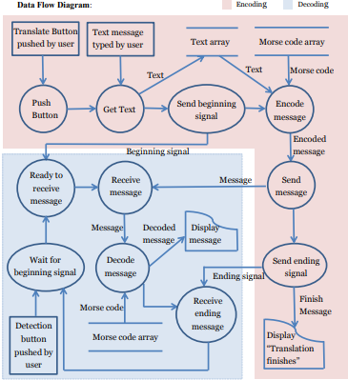

The decode part is basically is basically an image processing thing. What we need to do can be simply explained as gets the image and analyzes the image. Details can be realized in this way:

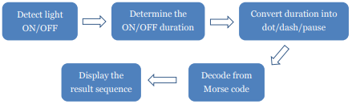

The problems here are how we can address image efficiently (when the image changes all the time) and how we can decide the light ON/OFF time precisely. Different devices’ cameras have different fps (frames per second) as well. The emission frequency is seriously limited by the fps value. If the emission frequency was not controlled appropriately, the reception part may not able to receive the flash light frequency correctly.

According to this tree, using if-else-if to decide whether the code exists or not and display correct code.
When come across dot, enter the left sub tree, when come across dash, enter the right sub tree.
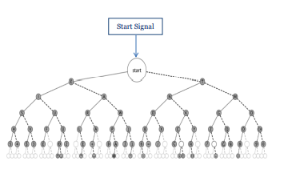
Besides the tree above, we also add an end signal. In any node inside the tree, when come across the end signal, just stop decoding.

METHODOLOGY:

Encryption of code:

- In case of encryption we extract each character (if not a space) from a word one at a time and match it with its corresponding morse code stored in whichever data structure we have chosen(if you are coding in python, dictionaries can turn out to be very useful in this case)

- Store the morse code in a variable which will contain our encoded string and then we add a space to our string which will contain the result.

- While encoding in morse code we need to add 1 space between every character and
consecutive spaces between every word.

- If the character is a space then add another space to the variable containing the result. We repeat this process till we traverse the whole string.

Decryption of code:

- In case of decryption, we start by adding a space at the end of the string to be decoded (this will be explained later).

- Now we keep extracting characters from the string till we are not getting any space.

- As soon as we get a space we look up the corresponding English language character to the extracted sequence of characters (or our morse code) and add it to a variable which will store the result.

- Remember keeping track of the space is the most important part of this decryption process. As soon as we get 2 consecutive spaces we will add another space to our variable containing the decoded string.

- The last space at the end of the string will help us identify the last sequence of morse code characters (since a space acts as a check for extracting characters and start decoding them).

Chapter 3: ROLES AMONG STUDENTS

This is to declare that every individual of our team has sincerely contributed to the successful completion project within the specified period of time.

The members accounting to the completion of project named “Morse code translator” are Miss Nidhi Bharti, Mr. Shivanshu Singh and Miss Kumari Sneha.

The work was divided into fragments so that each member receives equal work load. The programs were divided into sections for different team members to do and frames were divides to be done.

This also led to accuracy of the program as it was checked over and over again. So in context to role sharing we can say we managed to get everything quite equally. All the team members were mutually helpful to each other in the completion of the overall “Morse code converter”.

Firstly the designing of the page layout was given to Mr. shivanshu singh, then implementations for the classic model was done by Miss sneha, then finally placements of widgets were added by Miss Nidhi. Later ‘class and objects’ were applied to the main frame of widgets and the functions were divided mutually and the overall response of the team has been really heartwarming.

Later on new concepts were searched through the web and implemented to guide all the individuals to a new path of light of knowledge.

The result was pretty much appreciated by the individuals as the outcome was achieved with success and in a manner of peace amongst all.

Chapter 4: IMPLIMENTATIONS OF SCHEDULED WORK OF PROJECT

First, we obtained by the execution of the program in any suitable IDE, here used
PyCharm for python shell The program is successfully complied and run in the same. Further, the implementation is shown here in flow pattern here.

- Run program

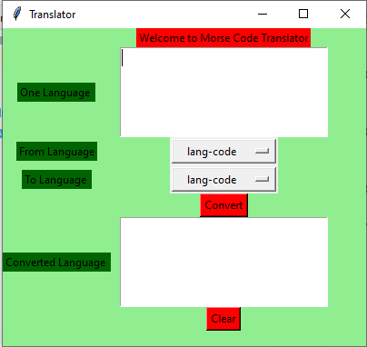

- Then convert from English word to morse code
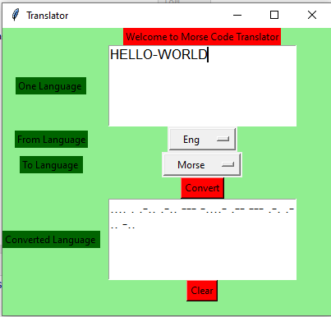
- And From convert morse code to English word
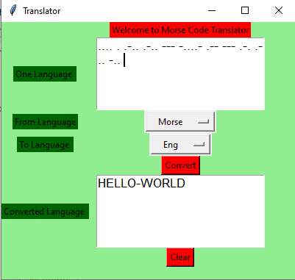
- When we use same language to convert, then compiler gives error
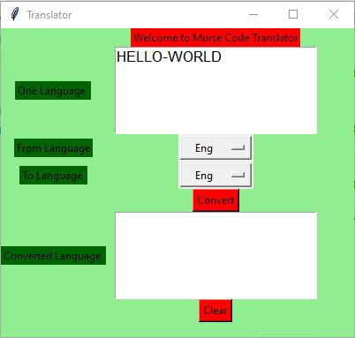

We can’t be use same language

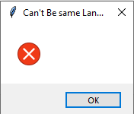

Chapter 5: TECHNOLOGIES AND FRAMEWORK USED

The morse code encoder is a electronic device that is used to set the text message to code format. Most commonly used encoders in digital electronics. The below image contains the complete schematic diagram of the morse coder device.
The aim of this circuit is to convert the text to morse code based on programming. This circuit is developed by using a microcontroller of PIC16f family is operates with 20 MHz crystal to provide higher speed operations. The PS/2 keyboard is an analogue keyboard used as an input device. The buzzer is used to indicate the key is pressed on the keyboard.
The morse code is a method of sending information by entering in a series of electronic pulses which represents as a short pulse (called a “dot”) and long pulses (called a “dash”). The entire message will be sent by using these two characters or signals.
Morse code dictionary:
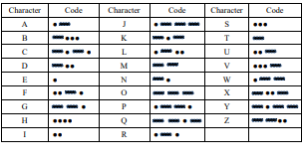
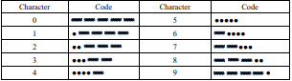

Chapter 6: SWOT ANALYSIS

Strengths:

- Cheap

- Wireless

- Easy to send
- No interference

Weakness:

- Learning the morse code

- Time consuming

- The beam of light can be interrupted

Opportunities:

- Morse code is a way to communicate using tones and clicks when you are unable to speak or do not want your conversation to be detected.

- Letters of a word are separated by a space equal to three dots and words are separated by a space equaling seven dots.

- Morse code can be used anywhere around the world. You just have to be able to translate the code into letters to spell out words.

- It is still used in the armed forces today as a means of communication.

Chapter 7: IMPLEMENTATION

Python provides a data structure called dictionary which stores information in the form of key-value pairs which is very convenient for implementing a cipher such as a Morse code. We can save the morse code chart in a dictionary where (key -value pairs) => (English character – morse code). The plaintext (English characters) take the place of keys and the ciphertext (Morse code) form the values of the corresponding keys. The values of keys can be accessed from the dictionary in the same way we access the values of an array through their index and vice versa. We know that we have hashmaps in python which is a form of data used to find the frequency of characters in a string.

Chapter 8: CONCLUSION

This is the implementation of MORSE CODE translator using python. This system was designed to transmit message securely to long distance. The design makes use of a programming language python. This design can be used in different areas like long communication, military, external affairs etc. By using this system there is no need of tapping device for transmission. so this overcomes the security problems.

Chapter 9: REFRENCES

Here are some honorable references used for completion of the project:

- Google

- Wikipedia

- Introduction to programming using python by Y. Daniel Liang.

- Python Programming: Using problem solving approach by Ankit Rai.

Github link: https://github.com/Nidhi-Bharti2407

